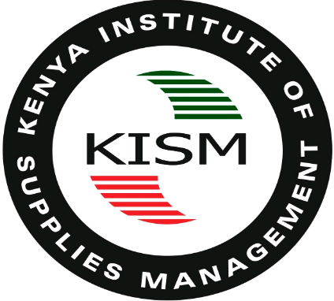

REMARKS BY THE CHIEF EXECUTIVE OFFICER OF THE KENYA INSTITUTE OF SUPPLIES MANAGEMENT (KISM) AT THE SUPPLY CHAIN & LOGISTICS SUMMIT EAST AFRICA 2024 ON WEDNESDAY, 8 MAY 2024 AT SAROVA STANLEY HOTEL, NAIROBI.

Chairman KISM,
Professional Colleagues,
Ladies and Gentlemen,
Good morning!

- Am pleased to join you at this Supply Chain & Logistics Summit East Africa 2024. It's an honor to stand before you today as we gather to explore the theme of "Building Resilience and Improving Efficiencies In Your Supply Chain."

- In the ever-evolving landscape of global trade and commerce, the importance of a robust and agile supply chain cannot be overstated. It serves as the backbone of our businesses.

- As we navigate the complexities of today's marketplace, resilience has emerged as a critical attribute for supply chain success. The ability to adapt to disruptions, whether they be natural disasters, geopolitical tensions, or global pandemics, is essential for maintaining continuity and safeguarding operations.

- At the same time, we must also focus on improving efficiencies within our supply chains. By streamlining processes, optimizing inventory management, and leveraging technology, we can drive down costs, enhance productivity, and deliver greater value to our customers.

- At the Kenya Institute of Supplies Management, we are committed to equipping professionals with the knowledge, skills, and tools needed to thrive in this dynamic environment. Through our training programs, certification courses, and industry partnerships, we strive to cultivate a professional practitioners that are agile, innovative, and forward-thinking.

- I hope all of you are members of KISM and if not, don’t worry, we have a desk here that will facilitate the process of membership. Remember when we work together as professionals we shall go far.

- As we engage in discussions and share best practices, I encourage each of you to reflect on how you can strengthen the resilience and efficiency of your supply chain. Let us seize this opportunity to learn from one another, collaborate on solutions, and chart a course towards a more resilient and prosperous future.

Thank you for your participation, and I wish you all fruitful deliberations ahead.

Kenneth Matiba
Chief Executive Officer
Kenya Institute Supplies Management

8th May, 2024
@ Sarova Stanley, nairobi

